Lab Manual
Practical and Skills Development

CERTIFICATE

THE ASSIGNMENT ENTERED IN THIS REPORT HAVE BEEN SATISFACTORILY PERFORMED BY

Registration No | :25BHI10125
Name of Student | :AYUSH SAXENA
Course Name | : Introduction to Problem Solving and Programming
Course Code | : CSE1021
School Name | : School of Computing Science
Engineering and Artificial Intelligence (SCAI)
Slot : B11+B12+B13
Class ID : BL2025260100796
Semester : FALL 2025/26

Course Faculty Name : Dr. Hemraj S. Lamkuche

Signature:

Practical Index
S. No. | Title of Practical | Date of Submission | Signature of Faculty
1 | Lucas Numbers | 16/11/20225
2 | Chinese Remainder Theorem (CRT)  Solver | 16/11/20225
3 | Quadratic Residue Check | 16/11/20225
4 | Order of an Element Modulo n | 16/11/20225
5 | Fibonacci Prime Check | 16/11/20225

Practical No: 1
Date: 10/11/2025

TITLE: Write a function Lucas Numbers
Generator lucas_sequence(n) that generates the first n Lucas numbers (similar to Fibonacci but starts with 2,
1).

AIM/OBJECTIVE(s): To write a Python function mod_inverse(a, m) that finds the integer $x$ such that $(a \cdot x) \equiv 1 \pmod m$. The script should also measure the execution time and peak memory usage.

METHODOLOGY & TOOL USED:

Python programming language

BRIEF DESCRIPTION:
mod_inverse(a, m) that calculates the modular multiplicative inverse.
It returns None if the modulus m is invalid ($m \le 1$) or if the inverse does not exist (caught by ValueError).

RESULTS ACHIEVED:
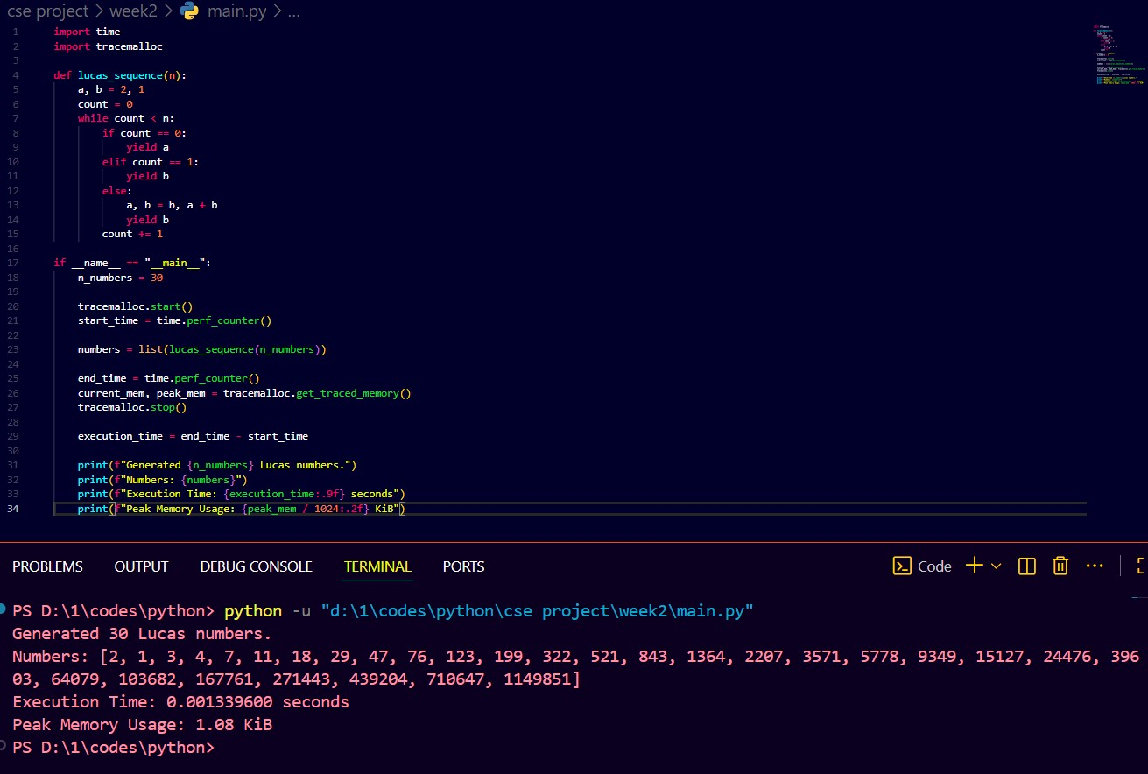

SKILLS ACHIEVED:
- Understanding the concept of a modular multiplicative inverse.
- Using Python's pow() function for advanced number theory operations.
- Using try...except blocks to handle expected mathematical errors (ValueError).
- Continued practice in performance measurement.

Practical No: 2
Date: 16/11/2025

TITLE: Chinese Remainder Theorem (CRT) Solver

AIM/OBJECTIVE(s) : Chinese Remainder Theorem (CRT) Solver

METHODOLOGY & TOOL USED:Python programming language

BRIEF DESCRIPTION:
The code defines a crt function that solves a system of congruences using the standard constructive algorithm for the Chinese Remainder Theorem. It relies on the mod_inverse helper function.

Result:
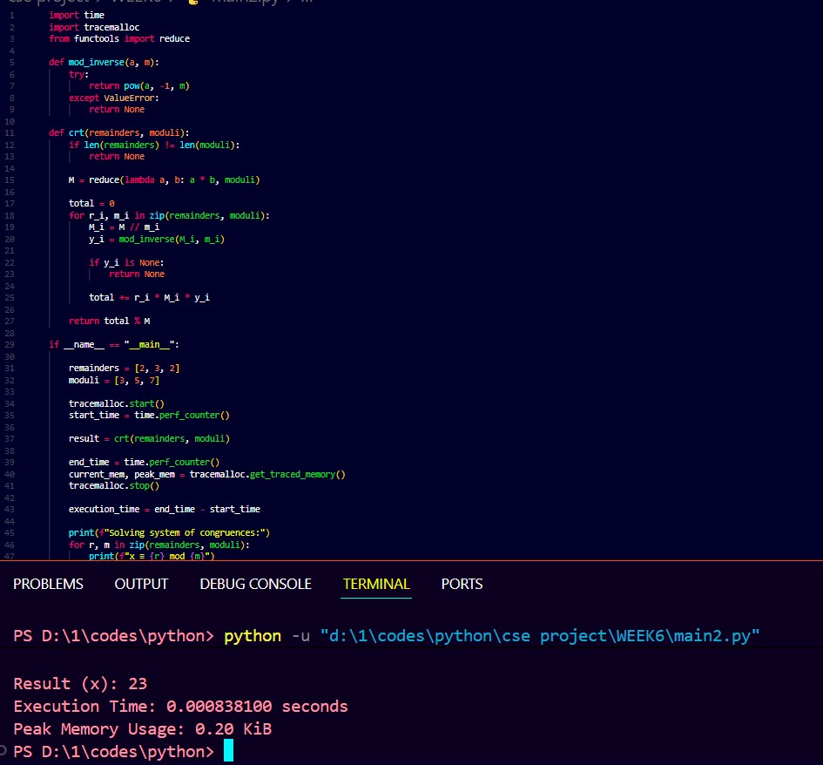
SKILLS ACHIEVED :
- Understanding and implementing the Chinese Remainder Theorem algorithm.
- Combining multiple functions (crt and mod_inverse) to solve a complex problem.
- Using zip to iterate over multiple lists simultaneously.

Practical No: 3
Date: 16/11/2025

TITLE :Quadratic Residue Check

AIM/OBJECTIVE(s):To write a Python function
is_quadratic_residue(a, p) that checks if the congruence $x^2 \equiv a \pmod p$ has a solution, assuming $p$ is a prime number.

METHODOLOGY & TOOL USED
Python programming language

BRIEF DESCRIPTION:
The code defines a function is_quadratic_residue(a, p) that implements Euler's criterion to determine if a is a quadratic residue modulo p. It handles the special case of p=2 and the trivial case of a=0
RESULTS ACHIEVED:
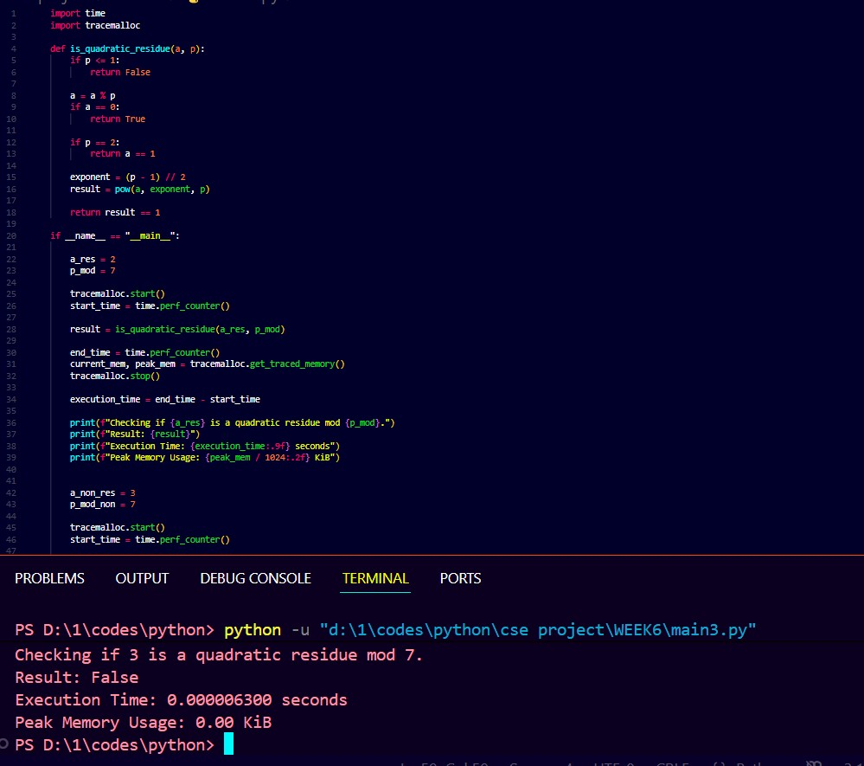
SKILLS ACHIEVED:
- Understanding the concept of quadratic residues.
- Implementation of Euler's criterion.
- Efficient modular exponentiation using pow().
- Handling edge cases in number theory problems (e.g., $p=2$).

Practical No: 4
Date: 16/11/2025

TITLE:Order of an Element Modulo n

AIM/OBJECTIVE(s) : To write a Python function order_mod(a, n) that finds the smallest positive integer k (the order) such that a^k= 1 mod(n)

METHODOLOGY & TOOL USED:
Python programming language

BRIEF DESCRIPTION :
Python function order_mod(a, n) that finds the smallest positive integer k (the order) such that a^k= 1 mod(n)
- Order of 3 (mod 7). (φ(7)=6, divisors are 1, 2, 3, 6).
- Order of 5 (mod 24). (φ(24)=8, divisors are 1, 2, 4, 8).

Result:
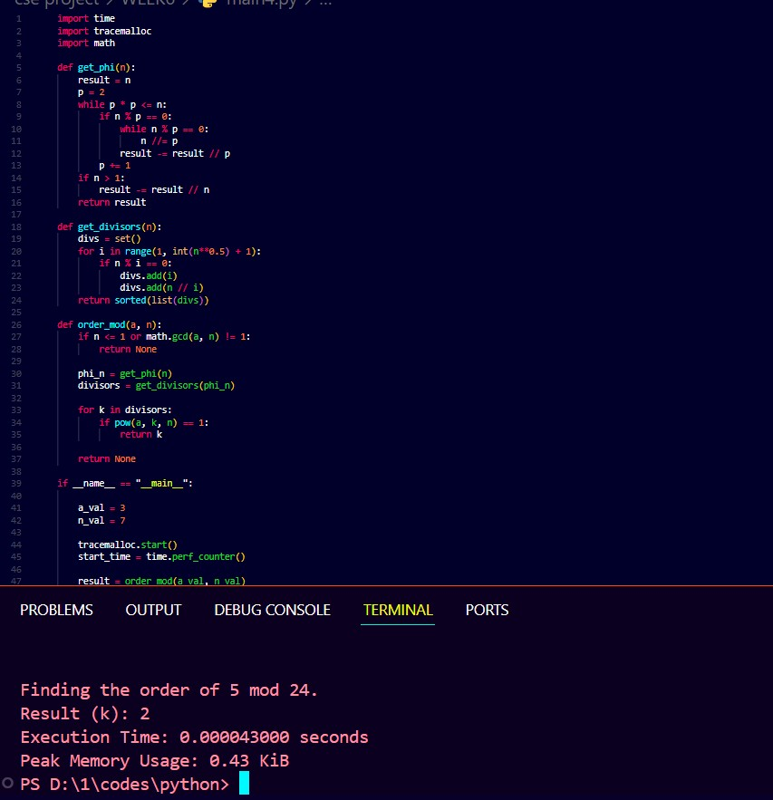
SKILLS ACHIEVED :
- Understanding the "order" of an element in a modular group.
- Implementation of Euler's totient function.
- Algorithm to find all divisors of a number.
- Applying number theory (Lagrange's/Euler's theorem) to optimize an algorithm.

Practical No: 5
Date: 16/11/2025

TITLE:Fibonacci Prime Check

AIM/OBJECTIVE(s):
To write a Python function is_fibonacci_prime(n) that checks if a given integer n is both a Fibonacci number and a prime number.

METHODOLOGY & TOOL USED:Python programming language

BRIEF DESCRIPTION:
The code defines is_fibonacci_prime(n) along with its required helper functions. The is_fibonacci check is based on a mathematical property, avoiding the need to generate Fibonacci numbers.
The main execution block (if __name__ == "__main__":) measures the time and memory for two cases:
- 13 (which is both prime and Fibonacci).
- 21 (which is Fibonacci but not prime).

RESULT:
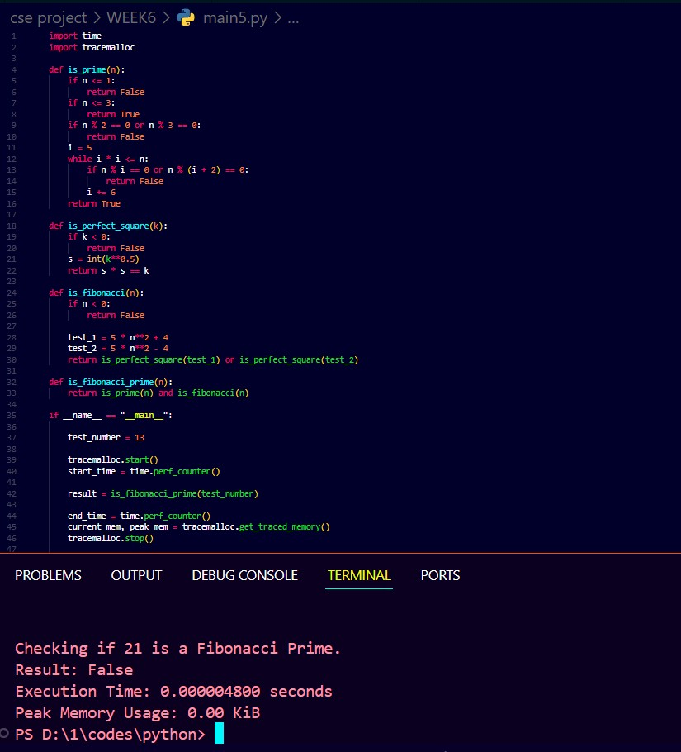

SKILLS ACHIEVED:
- Understanding and implementing mathematical properties of number sequences.
- Writing helper functions to build up complex logic (is_perfect_square, is_fibonacci, is_prime).
- Combining logical conditions (and) to satisfy multiple criteria.

